ARE RIGHT, A LOT

Definition and Indicators
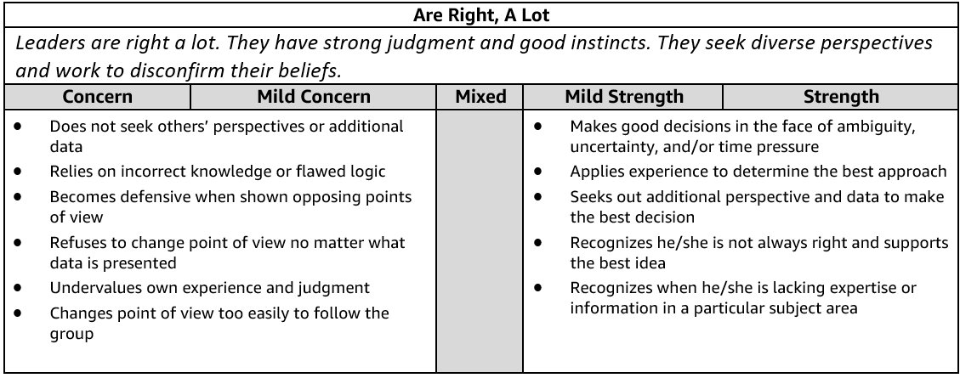

Are Right, A Lot - Suggested Behavioral Interview Questions
Please choose 2-3 questions below for your interview.

- Tell me about a time when you didn't have enough data to make the right decision. What did you do? What path did you take? Did the decision turn out to be the correct one?
- Tell me about a strategic decision you had to make without clear data or benchmarks. How did you make your final decision? What alternatives did you consider? What were the tradeoffs of each? How did you mitigate risk?
- Tell me about a time when you made a difficult decision with input from many different sources (customers, stakeholders, partner teams, etc.). What was the situation and how did you arrive at your decision? Did the decision turn out to be the correct one? Why or why not?
- We don't always make the right decision all the time. Tell me about a time when you made a bad decision. What was the impact of that decision? What did you learn? How have you applied what you learned?
- We don't always make the right judgment all the time. Tell me about a time when you made an error in judgment. What was the impact? What did you learn? How have you applied what you learned?
- Tell me about a time when you discovered that your idea was not the best course of action. What was your idea? Why wasn't your idea the best course of action? How did you find out it was not the correct path? What was the best course of action? Who provided it? What did you learn from the experience?
- Describe a time when you brought different perspectives together to solve a problem. What types of different perspectives were represented? How did you seek out different points of view? What was the outcome? Where there any key learnings from this experience? Knowing what you know now, would you have done anything different?

BIAS FOR ACTION

Definition and Indicators
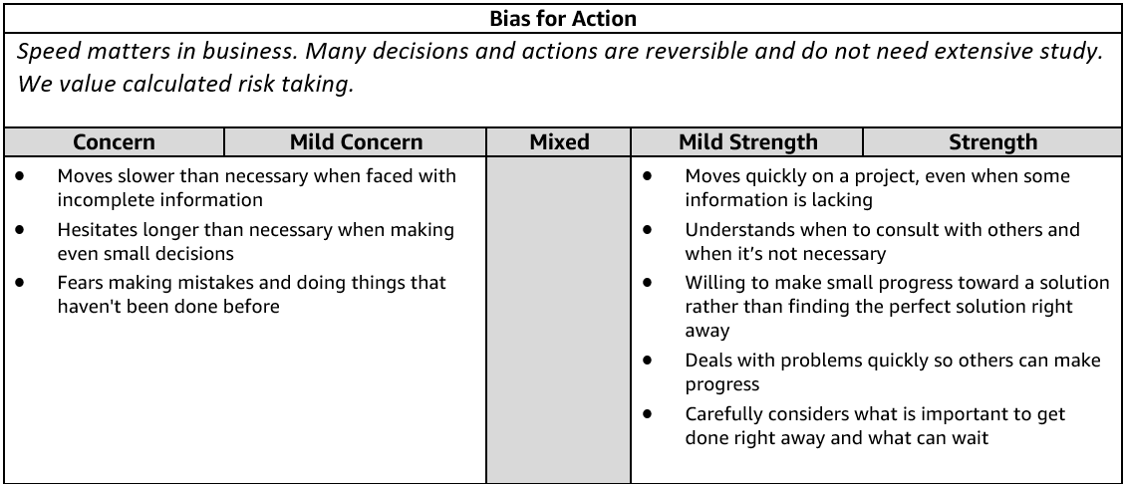
Bias for Action - Suggested Behavioral Interview Questions
Please choose 2-3 questions below for your interview.

- Give me an example of a calculated risk that you have taken where speed was critical. What was the situation and how did you handle it? What steps did you take to mitigate the risk? What was the outcome? Knowing what you know now, would you have done anything differently?
- Tell me about a time when you worked against tight deadlines and didn't have time to consider all options before making a decision. How much time did you have? What approach did you take? What did you learn from the situation?
- Describe a situation where you made an important business decision without consulting your manager. What was the situation and how did it turn out? Would you have done anything differently?
- Tell me about a time when you had to gather information and respond immediately to a situation. What was the outcome? Would you have done anything differently?
- Give me an example of when you had to make an important decision and had to decide between moving forward or gathering more information. What did you do? What was the outcome? What information is necessary for you to have before acting?
- Tell me about a time when you saw an issue that would impact your team and took a proactive approach to solve it. What was the issue? What did you do and what was the outcome? What did you learn from this situation?
- Tell me about a time when you felt your team was not moving to action quickly enough. What was the situation? What did you do? What was the outcome? Would you have done anything differently? (Manager)
- Tell me about a time when you were able to remove a serious roadblock/barrier preventing your team from making progress. What was the barrier? How were you able to remove it? What was the outcome? Knowing what you know now, would you have done anything differently? (Manager)

CUSTOMER OBSESSION

Definition and Indicators
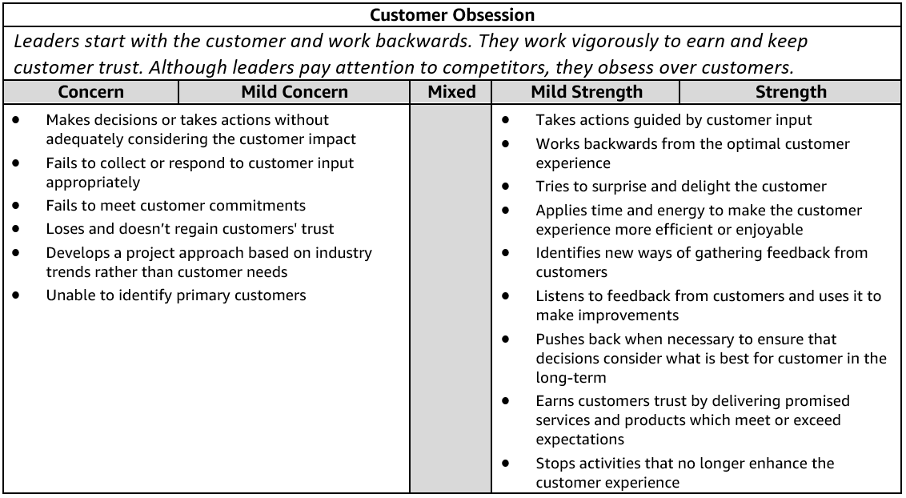
Customer Obsession - Suggested Behavioral Interview Questions
Please choose 2-3 questions below for your interview.

- Describe a difficult interaction you had with a customer. How did you deal with it? What was the outcome? How would you handle it differently?
- Tell me about a time when you went above and beyond for a customer. Why did you do it? How did the customer respond? What was the outcome?
- Give me an example of when you were able to anticipate a customer need with a solution/product they didn't know they needed/wanted yet. How did you know they needed this? How did they respond?
- Give me an example of a time when you asked for customer feedback. How did you use that feedback to drive innovation or improvement? How did the customer respond?
- Tell me about a time when you evaluated the customer experience of your product or service. What did you do? What was the result?
- Tell me about a time when a customer came to you for something that wouldn't actually address their need. How did you approach the situation? What was the result?
- Sometimes customers make unreasonable requests. Tell me about a time when you've had to push back or say no to a customer request. What did you say or do in response to that request?
- Tell me about a time when you had to balance the needs of the customer with the needs of the business. What did you do? What was the result?
- Give me an example of a change you implemented in your current team or organization to meet the needs of your customers. What has been the result? (Manager)

DELIVER RESULTS

Definition and Indicators
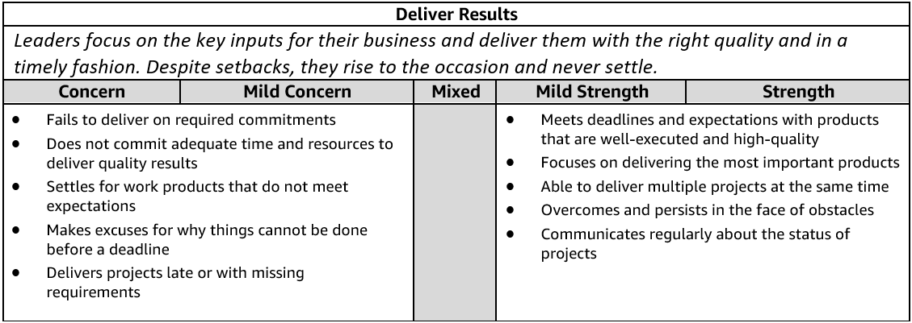
Deliver Results - Suggested Behavioral Interview Questions
Please choose 2-3 questions below for your interview.

- Give me an example of a time when you were able to deliver an important project under a tight deadline. What sacrifices did you have to make to meet the deadline? How did they impact the final deliverable? What was the final outcome?
- Tell me about a time when you had significant, unanticipated obstacles to overcome in achieving a key goal. What was the obstacle? Were you eventually successful? Knowing what you know now, is there anything you would have done differently?
- Tell me about a time when you not only met a goal but considerably exceeded expectations. How were you able to do it? What challenges did you have to overcome?
- Tell me about a time when you or your team were more than half way to meeting a goal when you realized it may not be the right goal or may have unintended consequences. What was the situation? What did you do? What was the outcome? Looking back, would you have done anything differently?
- Give me an example of a mission or goal you didn’t think was achievable. What was it and how did you help your team try to achieve it? Were you successful in the end? Looking back, would you have done anything differently?
- Tell me about a time when you did not effectively manage your projects and something did not get completed on time. What was the impact? What approaches do you use to make sure you are focusing on the right deliverables when you have several competing priorities?
- It can be difficult to set goals for a team that are challenging, yet achievable. Tell me about a time when you hit the right balance. How did you approach setting the goals? What was the outcome? (Manager)

DIVE DEEP

Definition and Indicators
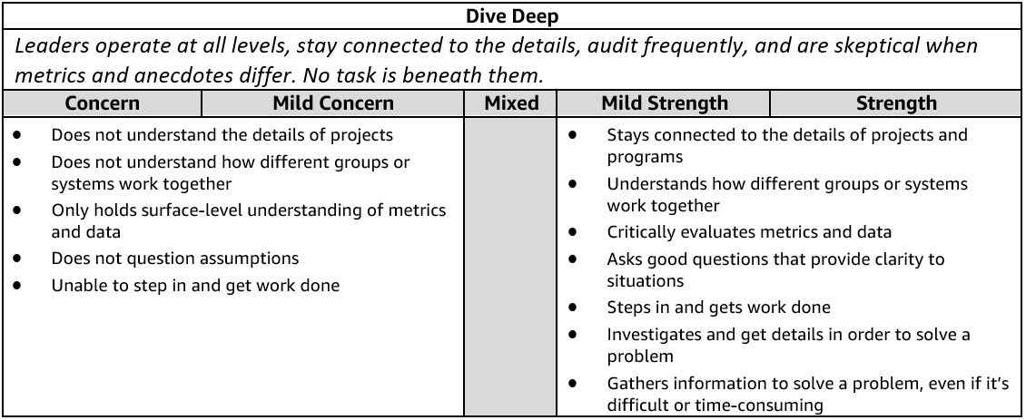
Dive Deep - Suggested Behavioral Interview Questions
Please choose 2-3 questions below for your interview.

- Tell me about a time when you were trying to understand a complex problem on your team and you had to dig into the details to figure it out. Who did you talk with or where did you have to look to find the most valuable information? How did you use that information to help solve the problem?
- Tell me about a situation that required you to dig deep to get to the root cause. How did you know you were focusing on the right things? What was the outcome? Would you have done anything differently?
- Tell me about a problem you had to solve that required in-depth thought and analysis. How did you know you were focusing on the right things? What was the outcome? Would you have done anything differently?
- Walk me through a big problem or issue in your organization that you helped to solve. How did you become aware of it? What information did you gather? What information was missing and how did you fill the gaps? Did you do a reflection at the conclusion of the project? If so, what did you learn?
- Tell me about a specific metric you have used to identify a need for a change in your department. Did you create the metric or was it already available? How did this and other information influence the change? What was the outcome of this change?
- Have you ever created a metric that helped identify a need for a change in your department? What was the metric? Why did you create it? How did this and other information influence change? What was the outcome of the change?
- Tell me about a time when you had to validate the assumptions underlying a direct report's project. How did you decide follow up was necessary? What steps, if any, did you take to validate the assumptions? What was the result? (Manager)

EARN TRUST

Definition and Indicators
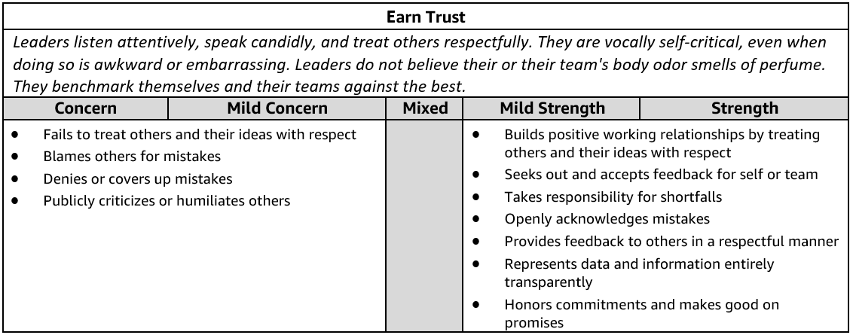
Earn Trust - Suggested Behavioral Interview Questions
Please choose 2-3 questions below for your interview.

- Tell me about a time when you had to communicate a change in direction that you anticipated people would have concerns with. What did you do to understand the concerns and mitigate them? Were there any changes you made along the way after hearing these concerns? How did you handle questions and/or resistance? Were you able to get people comfortable with the change?
- Give me an example of a tough or critical piece of feedback you received. What was it and what did you do about it?
- Describe a time when you needed to influence a peer who had a differing opinion about a shared goal. What did you do? What was the outcome?
- Give me an example of a time when you were not able to meet a commitment. What was the commitment and what were the obstacles that prevented success? What was the impact to your customers/peers and what did you learn from it?
- Tell me about a time when your team’s goals were out of alignment with another team you relied on in order to meet your goal. How did you work with the other team? Were you able to achieve your goals?
- Tell me about a time when you uncovered a significant problem in your team. What was it and how did you communicate it to your manager and other stakeholders? What did you do to address the problem? How did you manage the impact of this problem for the rest of your team?
- Describe a time when you improved morale and productivity on your team. What were the underlying problems and their causes? How did you prevent them from negatively impacting the team in the future?
- Tell me about a time when a team member was struggling to keep up or fit in and you stepped in to help out. Why did you think they were struggling or not fitting in? Why did you decide in step in and support? What did you do to help out? How did it impact your work? What was the outcome? What did you learn from that situation?
- Tell me about a time when a team member was not performing well and impacted your work. How did you handle that situation? Why were they not performing well? What was the outcome? What did you learn from that situation?

FRUGALITY

Definition and Indicators
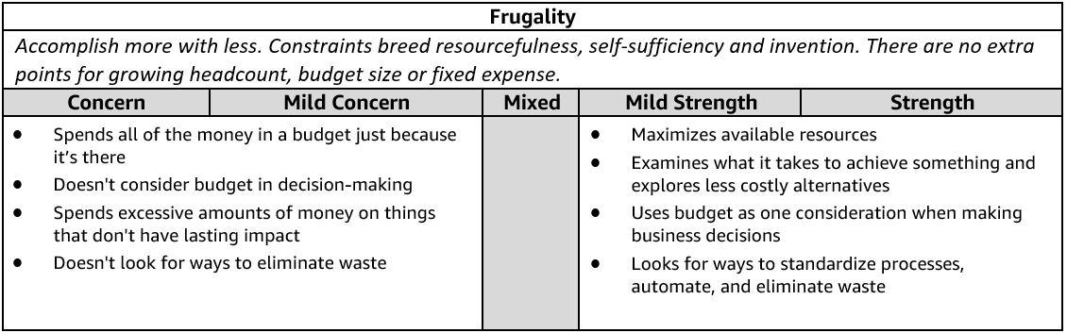
Frugality - Suggested Behavioral Interview Questions
Please choose 2-3 questions below for your interview.

- Give me an example of how you have helped save costs or eliminate waste within your role or organization. What was the situation? What was the impact?
- Describe a time when you had to get a project or initiative completed with limited resources. How did you approach the situation? What was the impact? Knowing what you know now, would you have done anything differently?
- Tell me about a time when you didn’t have enough resources to do something you felt was important but found a creative way to get it done anyway. What was the situation? What other options did you consider? How did you decide on a path forward? What was the outcome?
- Tell me about a time when you had to make tradeoffs between quality and cost. How did you weigh the options? What was the result? Would you have done anything differently?
- Tell me about a time when you generated a creative solution to a problem or project without requiring additional resources. What was the problem? What was the solution and how did you come up with it? What was the outcome?
- Give an example of a time you requested additional funding/budget to complete a project. Why was it needed? Did you try to figure out another approach? Did you get the additional resources? Why or why not?
- Describe a time when you had to decide whether or not to award or ask for additional resources. What criteria do you use for making the call? What was the outcome? Knowing what you know now, would you have done anything differently? (Manager)
- Give an example of a time when you challenged your team to come up with a more efficient solution or process. What drove the request? How did you help? What were some of your biggest challenges? What were the end results? (Manager)

HAVE BACKBONE; DISAGREE AND COMMIT

Definition and Indicators
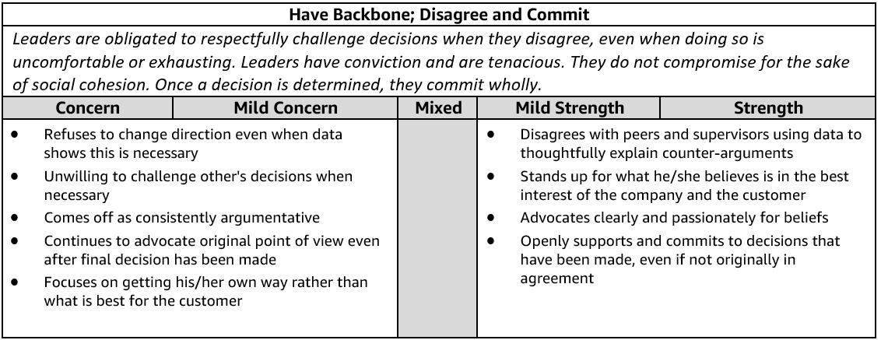
Have a Backbone; Disagree and Commit - Suggested Behavioral Interview Questions
Please choose 2-3 questions below for your interview.

- Tell me about a time when you strongly disagreed with your manager or peer on something you considered very important to the business. What was it and how did you handle it? Knowing what you know now, would you do anything differently?
- Describe a time when you took an unpopular stance in a meeting with peers and your leader. What was it? Why did you feel strongly about it? What did you do? What was the outcome?
- Often, we must make decisions as a group. Give me an example of a time you committed to a group decision even though you disagreed. What factors led you to commit to the decision? Would you make the same decision now?
- Describe a time when you felt really strongly about something on a project but the team decided to go in a different direction. How hard did you press the issue? How did you approach that project afterward?
- Tell me about a time when you pushed back against a decision that negatively impacted your team. What was the issue? How did it turn out? Would you have done anything differently?
- Give me an example of when you submitted a great idea to your manager and they did not support it. What was the idea? How did you handle the lack of support?
- Describe a time when you had to support a business initiative that you didn't agree with. How did you handle it? How did you deliver the message to your team?
- Tell me about a time when the business gained something because you persisted for a length of time. Why were you so determined? How did it turn out?

HIRE AND DEVELOP THE BEST
Definition and Indicators
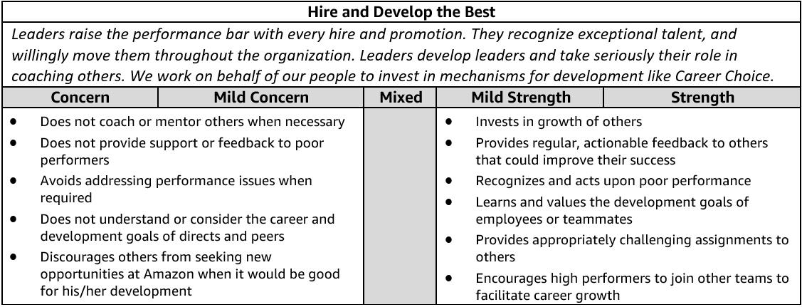
Hire and Develop the Best - Suggested Behavioral Interview Questions
Please choose 2-3 questions below for your interview.

- Tell me about a time when you helped one of your team members develop their career. How did you help that team member? What was the result?
- Tell me about a time when you invested in an employee's development. What did you invest in and why? What was the outcome? Can you share an example where investing in an employee's development didn't work out?
- Give me an example of a time you provided feedback to develop the strengths of someone on your team. Were you able to positively impact their performance?
- Tell me about a time when you provided coaching for a team member. What started the coaching? What was the outcome?
- Tell me about someone you hired that you thought complemented your skills. How did you coach an individual in areas where you have a weakness? (Manager)
- Tell me about a time when you helped a remote team member develop their career. Can you give me an example of a specific team member and how you helped them develop across the geographic distance? (Manager)
- Describe a person who struggled to get promoted under your leadership and how you helped facilitate their success. (Manager)
- Tell me about your most challenging talent review and promotion process that you conducted for your team. What made it challenging? What factors did you consider in your talent review? What factors did you consider in the promotion process? Did you incorporate a tool to counter unconscious bias? If yes, how? How do you manage perceptions of unfair treatment? What did you learn from this process? Knowing what you know now, would you have done anything different? (Manager)
- Describe a time when you constructed a team to accomplish a goal. What factors did you consider in constructing the team? Did you factor diversity into your team construction? How did you balance work requirements, team skill composition, and team stretch opportunities? What do you consider when you allocate work? How did you ensure team members were able to work effectively together? Would you have done anything differently? (Manager)
- Tell me about a time when you had a low performing individual on your team. How did you deliver feedback? Did their performance improve? (Manager)
INSIST ON THE HIGHEST STANDARDS

Definition and Indicators
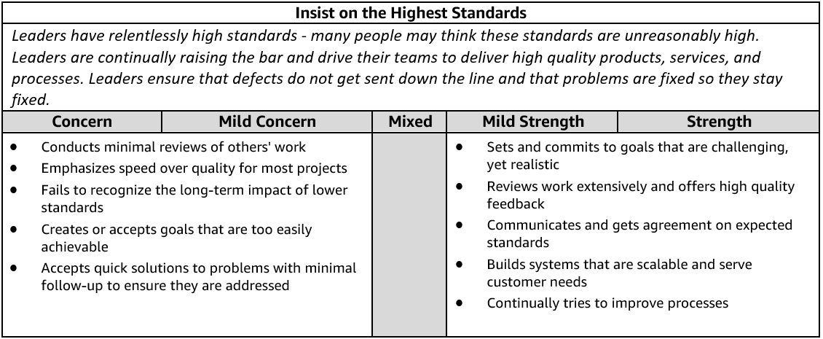
Insist on the Highest Standards - Suggested Behavioral Interview Questions
Please choose 2-3 questions below for your interview.

- Describe a time when you refused to compromise your standards around quality/customer service, etc. Who was your customer? What was the result?
- Tell me about a time when you were unsatisfied with the status quo. What did you do to change it? What was the impact? Would you do anything differently in the future?
- Tell me about a time when you worked to improve the quality of a product / service / solution that was already getting good customer feedback. Why did you think it needed improvement? How did customers react?
- Tell me about a time when you had to make a decision between standards and delivery. What tradeoffs did you have make? What was the outcome? Knowing what you know now, would you have done anything differently?
- Give me an example of a goal you’ve had where you wish you had done better. What was the goal? How could you have improved on it?
- Describe the most significant continuous improvement project that you led. What was the catalyst to this change and how did you go about it? What was the outcome?
- Tell me about a time when you used feedback about your team to drive a change. How did you gather or receive feedback on your team's performance? What was the outcome? (Manager)

INVENT AND SIMPLIFY

Definition and Indicators
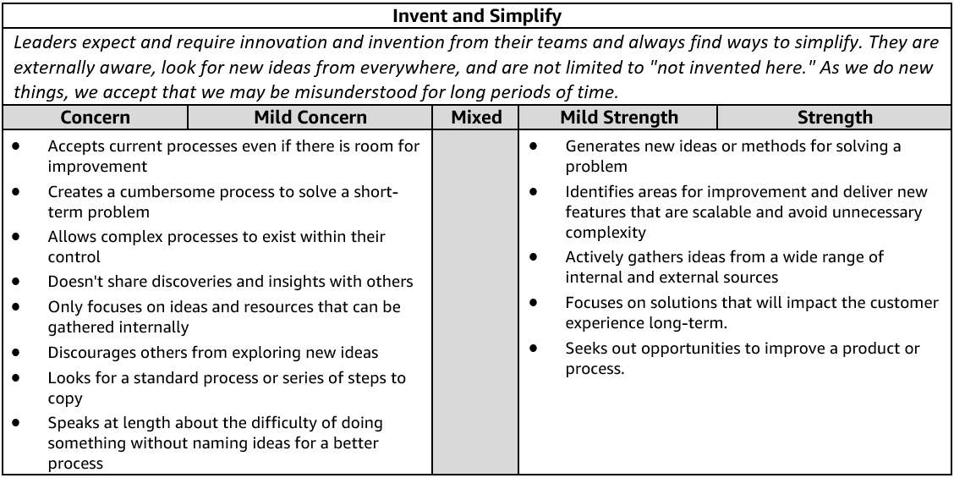
Invent and Simplify - Suggested Behavioral Interview Questions
Please choose 2-3 questions below for your interview.
- Give me an example of a complex problem you solved with a simple solution. What made the problem complex? How do you know your solution addressed the problem?
- Describe the most innovative thing you’ve done and why you thought it was innovative. Ask for one or two more examples to see if it's a pattern of innovative thinking. What was the problem it was solving? What was innovative about it?
- Tell me about a time when you were able to make something simpler for customers. What drove you to implement this change? What was the impact?
- Describe a time when you influenced and drove new thinking and innovation out of your team. Give an example of how your approach led to a specific innovation.
- Tell me about a time when you had a challenging problem or situation that the usual approach wouldn't address. How did you select an alternative approach? What alternative approach(es) did you consider? What was the end result? What was the impact?
- Tell me about a novel idea you had or decision you made that had a big impact on your business. What was novel about it?
- Tell me about a time when you enabled your team/a team member to implement a significant change or improvement. What problem were you trying to solve? How did you measure success? What was the end result/impact? (Manager)

Learn and Be Curious

Definition and Indicators
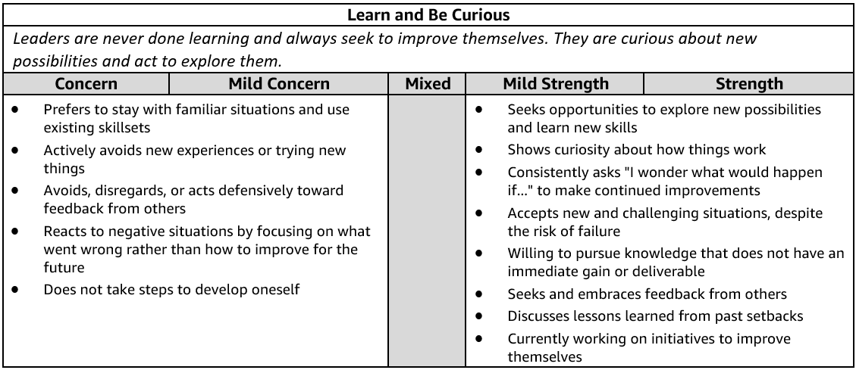
Learn and Be Curious - Suggested Behavioral Interview Questions
Please choose 2-3 questions below for your interview.

- Tell me about a time when you realized you needed a deeper level of subject matter expertise to do your job well. What did you do about it? What was the outcome? Is there anything you would have done differently?
- Describe a time when you took on work outside of your comfort area. How did you identify what you needed to learn to be successful? How did you go about building expertise to meet your goal? Did you meet your goal?
- Tell me about a time when you didn’t know what to do next or how to solve a challenging problem. How do you learn what you don't know? What were the options you considered? How did you decide the best path forward? What was the outcome?
- We all have things about ourselves we'd like to improve on at work. Give me an example of something that you've worked on to improve your overall work effectiveness. What resources did you identify to help you develop? What was the impact?
- Give me an example of a time when you explored a new or unexpected area of an existing space. Why hadn't this been explored already? Why did you move forward? What were the results or what was the impact?
- Describe a time when someone on your team challenged you to think differently about a problem. What was the situation? How did you respond? What was the outcome?
- Tell me about a time when you used external trends to improve your own company's products or services. How did you keep up to date with external trends? How did you decide to apply them to your own company? What was the result?

OWNERSHIP

Definition and Indicators
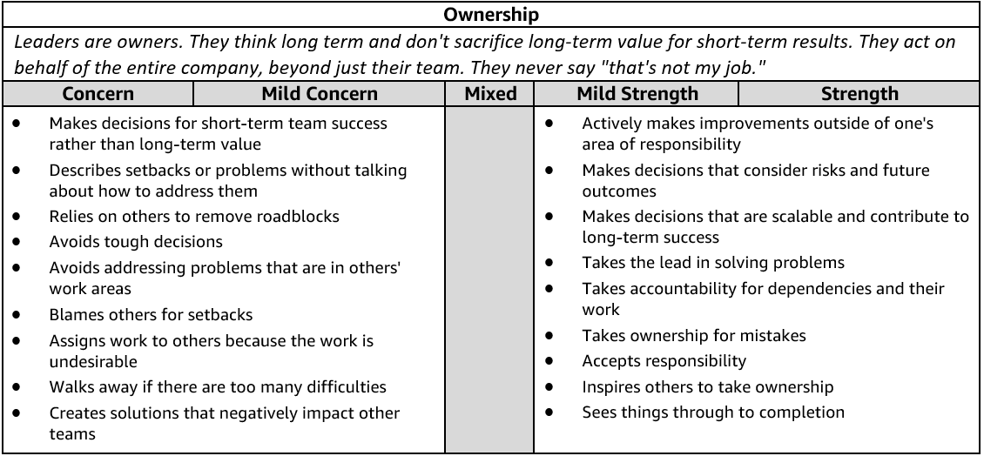
Ownership - Suggested Behavioral Interview Questions
Please choose 2-3 questions below for your interview.

- Tell me about a time when you took on something significant outside your area of responsibility. Why was it important? What was the outcome?
- Describe a time when you didn't think you were going to meet a commitment you promised. How did you identify the risk and communicate it to stakeholders? Is there anything you would do differently?
- Give me an example of an initiative you undertook because you saw that it could benefit the whole company or your customers, but wasn’t within any group’s individual responsibility so nothing was being done.
- Tell me about a time when you made a hard decision to sacrifice short term gain for something that would create long term value for the business. What was the outcome? Knowing what you know now, would you have done anything differently?
- Describe a time when you had to transition a project you owned to a new owner. What steps did you take to make sure the transition went smoothly? Tell me about a time that you chose to get involved in a project that you had already transitioned to somebody else. What was the situation? Why was it important to get involved?
- Tell me about a time when you saw a peer struggling and decided to step in and help. What was the situation? Why did you decide to step in? What actions did you take?

THINK BIG

Definition and Indicators
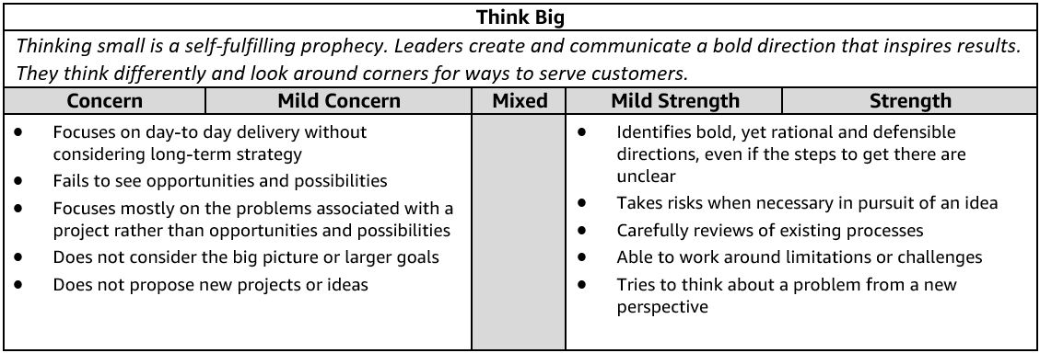
Think Big - Suggested Behavioral Interview Questions
Please choose 2-3 questions below for your interview.

- Tell me about time when you were working on an initiative or goal and saw an opportunity to do something much bigger or better than the initial focus. Did you take that opportunity? Why or why not? What was the outcome?
- Give me an example of how you have changed the direction or view of a specific function/department and helped them embrace a new way of thinking. Why was a change needed? What was the outcome?
- Give me an example of a time you proposed a novel approach to a problem. What was the problem and why did it require a novel approach? Was your approach successful?
- Tell me about a time when you drove adoption for your vision/ideas. How did you know your vision/idea was adopted by others? How did you drive adoption for your vision/ideas? How did you track adoption? Would you do anything differently?
- Give me an example of an idea or vision you had which was adopted by global stakeholders. How did you drive adoption for your vision/ideas? How did you track adoption? Would you do anything differently?
- Tell me about a time when you thought differently to improve a process that was working. What assumptions did you have to question? How did you evaluate if the change improved the process? Knowing what you know now, would you do anything differently?
- Tell me about a time when you encouraged a team member or organization to take a big risk. How did you balance the risk against existing business goals? What was the outcome? What did you learn from this situation? (Manager)
- Tell me about a time when you established a vision for a (team, product, initiative) when there wasn't one. How did you gain buy-in and drive execution? What was the outcome? Would you have done anything differently? (Manager)

STAR WORKSHEET
Your Behavioral Question: _________________________________________________________________
Leadership Principle: ______________________________________

- Choose behavioral question that provoke specific examples or stories for your assigned Leadership Principle(s).
- Process the example using STAR. Stories have beginnings (Situation/Task), middle (Actions) and ends (Results).
- Once you have established the story, PROBE to dive deeper on your assigned competency (Leadership Principle), get clarity or pursue a concern.
- If appropriate, CHALLENGE the candidate’s statements, decisions or thought process.
S  T | SITUATION/TASK - Describe the situation/task you faced and the context of the story  Answers the questions: where did this occur, when did it happen, why is it important?  Probing Questions:  - Why is this important? What was the goal?  - What was the initial scope of the project? What were the challenges?  - What were the risks and potential consequences if nothing happened?  Challenge Questions:  - Why did you choose this story to illustrate a xyz accomplishment?  - What other stories can you think of that demonstrate…xyz?  - Could you come up with an example that is more recent? | Notes
A | ACTION - What actions did you take?  Answers the questions: what did you personally own, how did you do it, who else was involved?  Probing Questions:  - Deep probe functional expertise and/or assigned core competency.  - Were you the key driver or project owner?  - What was your biggest contribution? What unique value did you bring?  - What were the most significant obstacles you faced? How did you overcome them?  Challenge Questions:  - What did you do specifically versus the team?  - How did you set priorities…deal with xyz problem… or get manager buy-in?  - What decisions did you challenge? Why? How did you influence the right outcome?
R | RESULTS - How did you measure success for this project? What results did you achieve?  $ Cost savings, revenue generation  # Quantify to understand volume, size, scale  % Percentage change, year over year improvements  Time to market, implementation time, time savings  Impact on the customer, the team  δ Quality improvements  Probing Questions:  - Why did you choose to focus on these results? What other results were important?  - You mentioned revenue, what percentage change is that year over year?  - What trade-offs did you have to make to achieve this? (quality, cost, time)  - I’m concerned about…(the time it took, the volume, the customer impact), tell me more…  Challenge Questions:  - What were the lessons learned? What would you have done differently?  - How would you implement this at Amazon?  - How did these results compare to your actual goals? (refer back to goal stated in Situation)

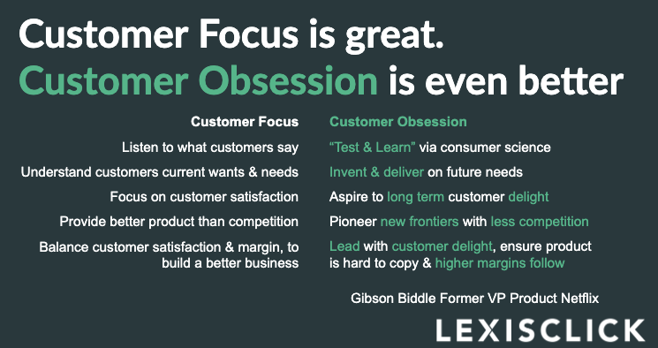

This worksheet was designed to help you align your experience with Amazon’s Leadership Principles. To best prepare for your interview, please write down a couple of detailed examples from your experience that relate to each of Amazon’s Leadership Principles.
Customer Obsession: Leaders start with the customer and work backwards. They work vigorously to earn and keep customer trust. Although leaders pay attention to competitors, they obsess over customers.
Example 1:
- S/T – Diverse partner/customer service (configurations, patches, NOS network operations, etc.) delivery tools, resulting in manual updates, more support tickets generated, delays, fragmented user experience, CSAT low and all this happening with a paid service. Task was to unify the delivery experience, Develop a single services platform
- A – Created a virtual connect platform vision, strategy and execution plan for a unified service delivery platform with services marketplace with try and buy capability and full remote service provision and delivery. Consolidated and retired 20+ other delivery tools.
- R – Key KPI & Outcomes 1) Deeper engagement between Cisco services and our customers. 2) Consistent user experience across customers, partners and Cisco, consistent look-and-feel for all interactions. 3) Outcome-based relationships with customers and partners 4) Drive new revenue streams with cross sell, upsell other services. 5) Achieve economies of scale and drive operational efficiency.
Example 2:
- S/T – The customer was looking to modernize its legacy testing lab infrastructure to a cloud based global testing with end-to-end digitization and workflow automation to respond quickly to market demands and new product innovation. One of the goals was also to eliminate application and infrastructure downtime along with improving user experience. Their challenge was to find the right partner who could help end-to-end in their cloud and digital transformation journey
- A - actions I took – I partnered with Client IT and other vendors to modernize and digitize global testing labs including delivering the following services:
  - Technical product assessments, Advise Product, Vendor Management and Procurement, Evaluate cloud Infrastructure options and make recommendation, Database, Application server options, Sizing, Scale, High Availability, Hosting decisions, AWS Account setup, Landing zone, design, Implement and Operate. Assistance with ISO review, Cost optimization, Managed Services setup and 24x7 monitoring and maintenance support defining responsibilities and expectations for infrastructure and application management by 3rd party vendor, Integrations with on-premises and internal applications like SAP, Bartender & RFID reader applications, LV SAP connector assessment, Master Data management, Configuration management, Data Analysis and Visualization
Solution Design
  - Perform assessment of the on-premises infrastructure and applications, Identified gaps and create overall system design
  - Architect a scalable & highly-available cloud solution as per AWS best practices & customer standards. Key components includes AWS Infrastructure as code, Application deployment, Backup and Disaster Recovery, Configuration management, End-to-end testing, Master data management and customization
  - Implement LV LIMS on AWS including workflow automation also address concerns on security and compliance. Collaborated extensively with various product vendors & technology partners for solution integration
Infrastructure/Application Implementation
  - Infrastructure Automation, Deploy and provision infrastructure through Cloud Formation to non-Prod and Prod Environments
  - Integrations to Active Directory, SAP, Bartender print, RFID and other on-premises systems
  - Technical Debt Recovery - Perform various upgrades including OS, Java JDK 1.8, LV versions, MS-SQL Server 2016
  - Key Services - AWS Cloud Formation, Shell scripting, Infrastructure and workflow automation, RHEL 7.4 SQL Server 2016, JBoss, Apache, SSO, VPC, IAM, Route53, EC2, EBS, ELB, SQS, SES, S3, VPC Peering, Auto scaling, RDS, MS-SQL, CloudWatch, CloudTrail, Systems Manager, Splunk, Trusted Advisor

Operations
  - Define SLAs and setup Managed Services operations, Configure security and remote access tools and hand-over to 3rd party support team for 24x7 application and infrastructure support
-R
- Digital transformation leading to faster decision making, product innovation and new revenue streams
- Global labs workflow simplification and automation results in eliminating manual data entry and physical hand-offs
- Improved customer experience with process simplification and better visibility of test data.
- Improved operational efficiency by faster provisioning of infrastructure, from weeks to less than 2 hours
- Improved business application performance. Significantly reduce downtime with Application and Infrastructure stability and resiliency

Ownership: Leaders are owners. They think long-term and don’t sacrifice long-term value for short-term results. They act on behalf of the entire company, beyond just their own team. They never say “that’s not my job.”
Example 1:
S/T - At Cisco Services I was part of the leadership team responsible to deliver platform enabled services to Cisco customers and partners, I Lead platform strategy and development for web and mobile service delivery, Part of my job is to ensure revenue growth and service success with platform innovation and operational efficiencies, Knowledge services I manage a global team of product, project management, business analysts and software development resources to deliver service delivery platform for platform-enabled services for Cisco network optimization service (NOS)
A - I developed partner version of KS Library service with content modularization and feature customizations to be sold through channel partners. I also developed the mobile strategy and developed IOS and Android applications to provide access to knowledge services anytime anywhere on any device. I lead cross-functional business initiatives to on-board new services on IC portal platform, I mange product management, engineering and governance across these entities for a unifying feature road map and user experience including defining strategic platform direction, next generation core development road map and release plans including strategy for mobile, XaaS, BI and Analytics.
R- Achieved fastest growing services with double digit growth and contributed to increased customer base by over 20% y/y. Successfully on-board 6 services existing services resulting in significant 30% operational savings to business
Example 2: ____________________________________________________________________________________________________________________________________________________________________________________________________________________________________________________________________________________________________________________________________________________________________________________________________________
Invent and Simplify: Leaders expect and require innovation and invention from their teams and always find ways to simplify. They are externally aware, look for new ideas from everywhere, and are not limited by “not invented here.” As we do new things, we accept that we may be misunderstood for long periods of time.
Example 1:
Remote managed service delivery is a key focus of Cisco services business strategy with numerous platforms and applications are under development for each of the service offers there is a need to consolidate and solidify critical service delivery elements to help establish service priorities and relevance for efficient one Cisco service delivery model.
The challenge services teams were facing was they had limited experience and resource constraints in offering remotely managed solutions. The situation was complicated by market pressures to introduce services to market quickly so various services group owners started to work on their own solution offers with no collaboration and coherent One Cisco strategy.

This resulted in a number of strategy and requirement gaps like new business models, redundant development, go to market inefficiencies that needed to be addressed.
I took the opportunity to address these gaps with a diverse group of teams to align to a common vision, strategy and execution model of One Cisco by establishing a consolidated remote services strategy and roadmap with clear scope and deliverables. I developed the unified service delivery strategy and socialized the new paradigm of agile service evolution with portfolio, sales, marketing and product management teams to get their buy –ins. With clearly articulated value propositions and competitive advantages I was able to get commitments from other teams to align with One Cisco delivery methodology.
This will help accelerate Cisco’s remote delivery strategy for delivering services rapidly and will provide the ability to respond faster to customer needs with better quality and cost.
Example 2: ____________________________________________________________________________________________________________________________________________________________________________________________________________________________________________________________________________________________________________________________________________________________________________________________________________
Are Right, A Lot: Leaders are right a lot. They have strong judgment and good instincts. They seek diverse perspectives and work to disconfirm their beliefs.
Example 1: ____________________________________________________________________________________________________________________________________________________________________________________________________________________________________________________________________________________________________________________________________________________________________________________________________________
Example 2: ____________________________________________________________________________________________________________________________________________________________________________________________________________________________________________________________________________________________________________________________________________________________________________________________________________
Hire and Develop the Best: Leaders raise the performance bar with every hire and promotion. They recognize exceptional talent, and willingly move them throughout the organization. Leaders develop leaders and take seriously their role in coaching others. We work on behalf of our people to invent mechanisms for development like career choice.
Example 1: ____________________________________________________________________________________________________________________________________________________________________________________________________________________________________________________________________________________________________________________________________________________________________________________________________________
Example 2: ____________________________________________________________________________________________________________________________________________________________________________________________________________________________________________________________________________________________________________________________________________________________________________________________________________
Insist on the Highest Standards: Leaders have relentlessly high standards—many people may think these standards are unreasonably high. Leaders are continually raising the bar and drive their teams to deliver high quality products, services and processes. Leaders ensure that defects do not get sent down the line and that problems are fixed so they stay fixed.
Example 1: ____________________________________________________________________________________________________________________________________________________________________________________________________________________________________________________________________________________________________________________________________________________________________________________________________________
Example 2: ____________________________________________________________________________________________________________________________________________________________________________________________________________________________________________________________________________________________________________________________________________________________________________________________________________

Think Big: Thinking small is a self-fulfilling prophecy. Leaders create and communicate a bold direction that inspires results. They think differently and look around corners for ways to serve customers.
Example 1: ____________________________________________________________________________________________________________________________________________________________________________________________________________________________________________________________________________________________________________________________________________________________________________________________________________
Example 2: ____________________________________________________________________________________________________________________________________________________________________________________________________________________________________________________________________________________________________________________________________________________________________________________________________________
Bias for Action: Speed matters in business. Many decisions and actions are reversible and do not need extensive study. We value calculated risk taking.
Example 1: ____________________________________________________________________________________________________________________________________________________________________________________________________________________________________________________________________________________________________________________________________________________________________________________________________________
Example 2: ____________________________________________________________________________________________________________________________________________________________________________________________________________________________________________________________________________________________________________________________________________________________________________________________________________
Frugality: Accomplish more with less. Constraints breed resourcefulness, self-sufficiency and invention. There are no extra points for growing headcount, budget size or fixed expense.
Example 1: ____________________________________________________________________________________________________________________________________________________________________________________________________________________________________________________________________________________________________________________________________________________________________________________________________________
Example 2: ____________________________________________________________________________________________________________________________________________________________________________________________________________________________________________________________________________________________________________________________________________________________________________________________________________

Learn and Be Curious: Leaders are never done learning and always seek to improve themselves. They are curious about new possibilities and act to explore them.
Example 1: ____________________________________________________________________________________________________________________________________________________________________________________________________________________________________________________________________________________________________________________________________________________________________________________________________________
Example 2: ____________________________________________________________________________________________________________________________________________________________________________________________________________________________________________________________________________________________________________________________________________________________________________________________________________
Earn Trust: Leaders listen attentively, speak candidly, and treat others respectfully. They are vocally self-critical, even when doing so is awkward or embarrassing. Leaders do not believe their or their team’s body odor smells of perfume. They benchmark themselves and their teams against the best.
Example 1: ____________________________________________________________________________________________________________________________________________________________________________________________________________________________________________________________________________________________________________________________________________________________________________________________________________
Example 2: ____________________________________________________________________________________________________________________________________________________________________________________________________________________________________________________________________________________________________________________________________________________________________________________________________________
Dive Deep: Leaders operate at all levels, stay connected to the details, audit frequently, and are skeptical when metrics and anecdote differ. No task is beneath them.
Example 1: ____________________________________________________________________________________________________________________________________________________________________________________________________________________________________________________________________________________________________________________________________________________________________________________________________________
Example 2: ____________________________________________________________________________________________________________________________________________________________________________________________________________________________________________________________________________________________________________________________________________________________________________________________________________

Have Backbone; Disagree and Commit: Leaders are obligated to respectfully challenge decisions when they disagree, even when doing so is uncomfortable or exhausting. Leaders have conviction and are tenacious. They do not compromise for the sake of social cohesion. Once a decision is determined, they commit wholly.
Example 1: ____________________________________________________________________________________________________________________________________________________________________________________________________________________________________________________________________________________________________________________________________________________________________________________________________________
Example 2: ____________________________________________________________________________________________________________________________________________________________________________________________________________________________________________________________________________________________________________________________________________________________________________________________________________
Deliver Results: Leaders focus on the key inputs for their business and deliver them with the right quality and in a timely fashion. Despite setbacks, they rise to the occasion and never settle.
Example 1: ____________________________________________________________________________________________________________________________________________________________________________________________________________________________________________________________________________________________________________________________________________________________________________________________________________
Example 2: ____________________________________________________________________________________________________________________________________________________________________________________________________________________________________________________________________________________________________________________________________________________________________________________________________________

